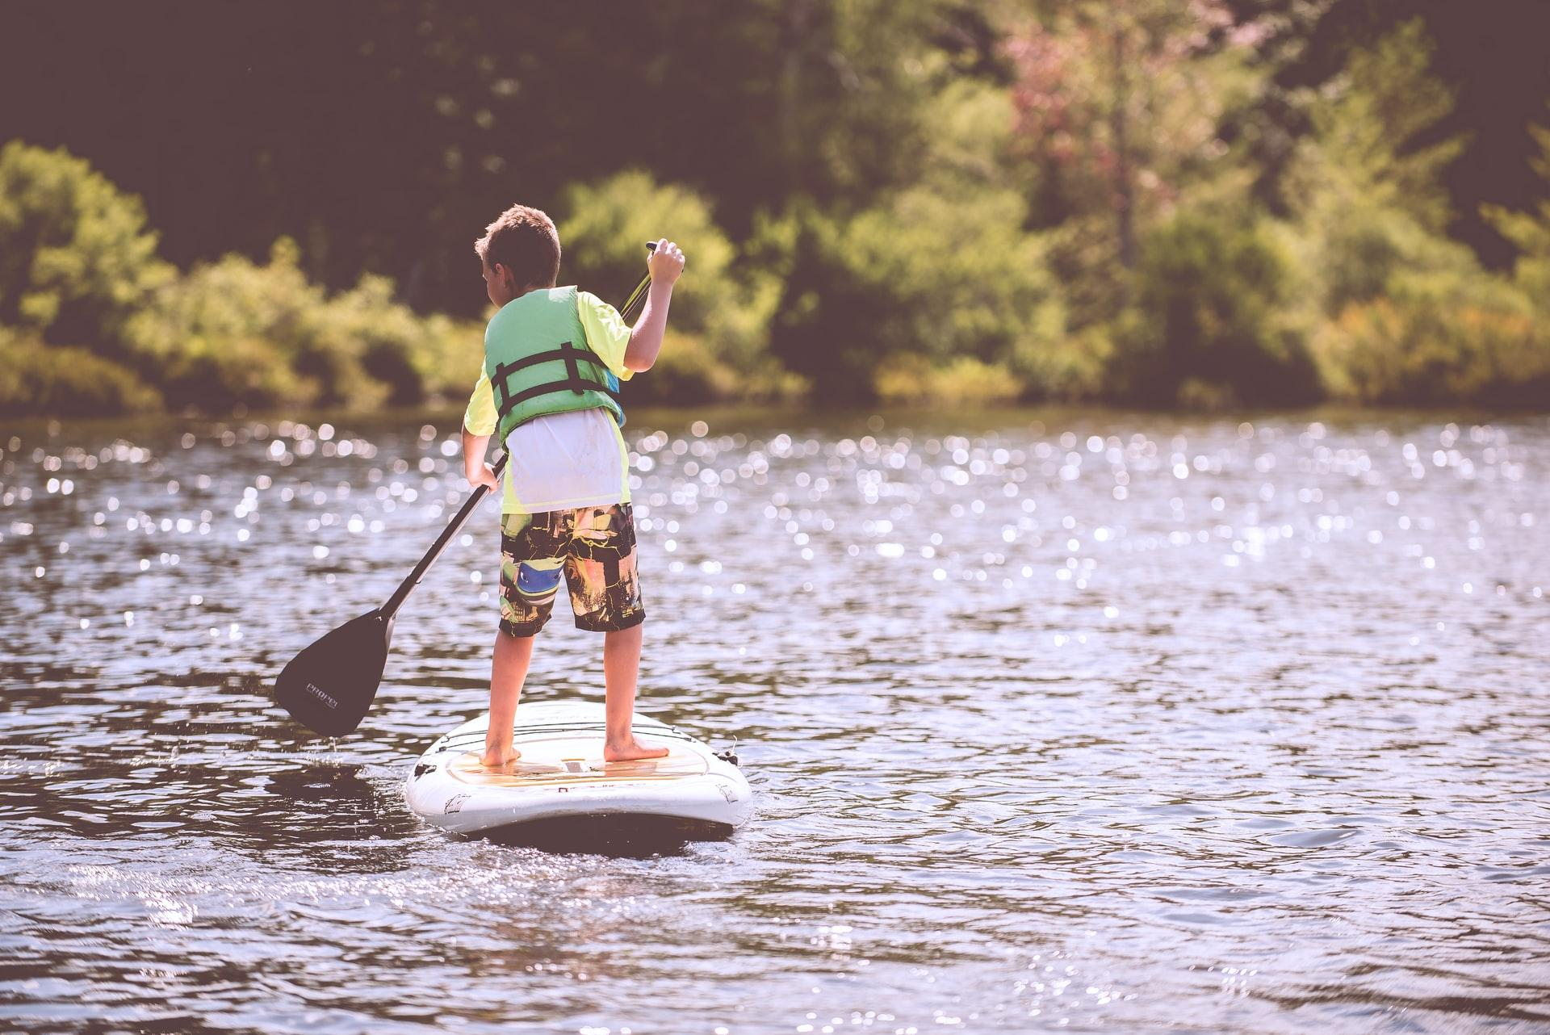

How Parents Can Get Children Outside and Get Away from Nature-Deficit Disorder

Nature-deficit disorder is a relatively unknown issue, but it’s one that is affecting children and families across the world. With kids spending less time outside, they are also spending less time receiving all of the benefits that our natural world has to offer. Of course, getting children outside can be half the battle for parents these days, but these fun and exciting resources can help.

Get Adventurous with Kids on Local Trails

If you want your kids to love nature, you need to make sure they are having fun. So, think about hitting up your local trails for some seriously exciting hiking, biking, and exploring.

4 Tips When Mountain Biking With Your Child
Wildlife Treasure Hunt Hikes
Other Ways to Make Hiking Fun for Kids
8 Lessons for Backpacking with Kids

Give Kids More Reasons to Play Outside

Your backyard can get your kids motivated to spend more time outside, especially if you invest in these incredibly cool backyard ideas.

DIY Backyard Playground: How to Create a Park for Kids
Creating a Magical Backyard Garden for Kids
Build a Backyard Playhouse for Your Children

Get Children Interested in Backyard Wildlife

Did you know that your backyard is its own little ecosystem? So, break out a few basic tools and get your kids out there to explore all of the critters that share your home with these tips.

Go on a Backyard Bug Hunt with Kids
Attract Local Birds with a Birdhouse
Teach Kids About Backyard Gardens
Create a Backyard Wildlife Sanctuary

Give Children Nature Activities for Rainy Days

Okay, so you can’t necessarily get outside with your kids every single day. To keep them interested in nature and the outdoors, you may also need these indoor activities and ideas.
Teach Children About Native American History with a Virtual Tour from MONAH
Storm Spotting for Children: At-Home Meteorology
Books That Teach Kids About the Environment
Indoor Nature Activities for Children
Top 10 Nature Documentaries for Kids

Fostering an interest in nature can help your kids flourish now, and later in life as well. So whether you’re up for an adventure or prefer to stay closer to home, help your kids understand how important it is to spend time outside. You will be so happy you did!

Photo Credit: Unsplash

